**Journey Through The Bible**

**THE GOOD SAMARITAN**

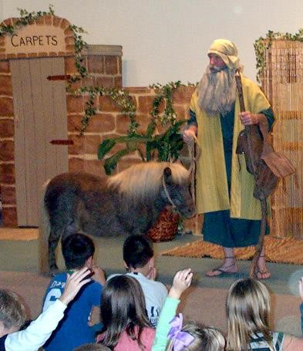

Luke 10:25-37

Once a man asked Jesus what to do to be saved, and Jesus told him to love God and to love his neighbor as he did himself. The man then asked Jesus who his neighbor was. Jesus told him my parable.

A man was on a journey from Jerusalem to Jericho. Robbers came after him and took all that he had, even his clothing. They left him in the road. The first man to come by was a lawyer who just looked at me and passed on by. The second man was a Levite and he too just looked at me and passed on by was well. These two men should have stopped and helped the man who had been robbed and beaten.

I am a Samaritan, and although my people are not very well thought of, I could not leave the man to die. I bandaged his wounds after I cleaned them. I put him on my animal and took him to an inn (hotel) where they could take care of him. I left money for his care, and I told the inn keeper that if he spent more than I left, I would pay him when I came back.

Jesus then asked me who I thought was the best neighbor. I answered and said, “I guess the Samaritan, was the best neighbor.” Jesus then told the beaten man to go and show mercy on people as I did. This is the thing we must do to live forever with Jesus. This story came from the book of Luke.

**Memory Verse:** Luke 10:27

**☼ You shall love the LORD your God with all your heart**

**What did this lesson tell me?**

**☺ Be Kind to EVERYONE!**

**Do you know? Answer on back page**

**?** What did the Samaritan do that pleased God?

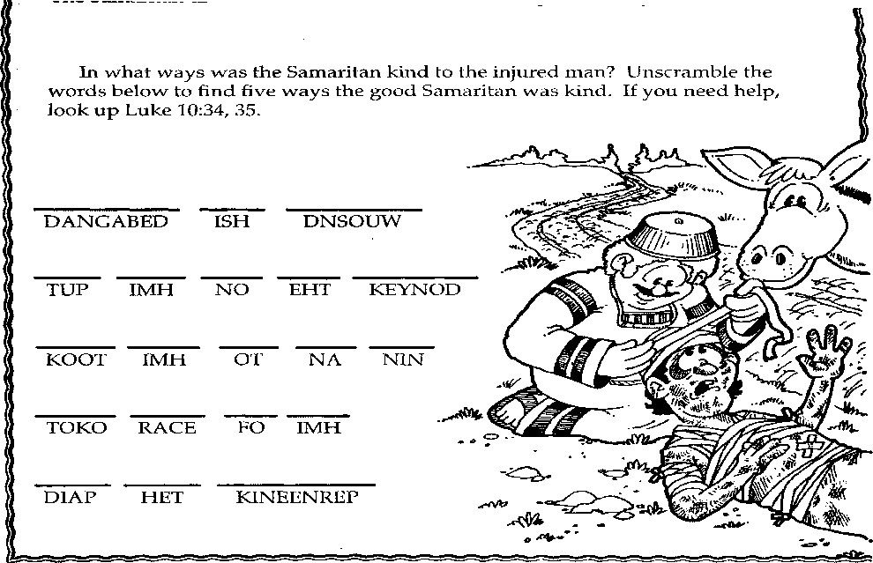

Luke 10:34-35 So he went to him and bandaged his wounds, pouring on oil and wine; and he set him on his own animal, brought him to an inn, and took care of him. On the next day, when he departed, he took out two denarii, gave them to the innkeeper, and said to him, 'Take care of him; and whatever more you spend, when I come again, I will repay you.'

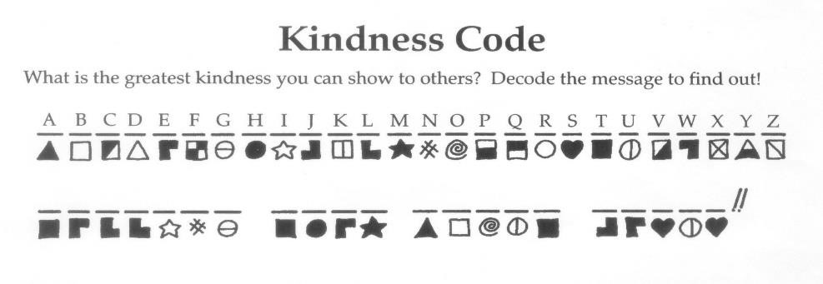

**Song**  Fran Weeks

Come and join us in our quest

To learn God’s word; you know it’s best. We learn from those of long ago

God’s truth that He wanted them to know.

Journey through God’s word tonight, The Bible teaches us what’s right.

Open God’s word and we will see

What the Journey Through the Bible reveals to Me

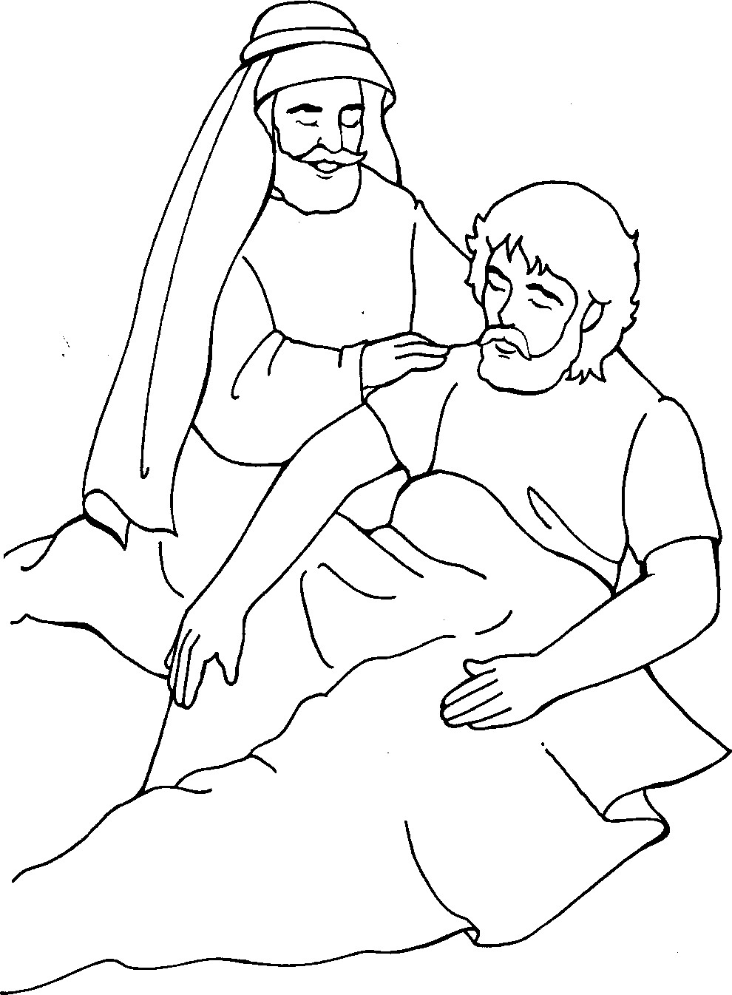

**?** Answer to do you know.

● He was kind by helping someone in need.